**Phonics**

We use the phonics scheme Read Write Inc. You can find out more about this scheme on this website: <https://www.ruthmiskin.com/programmes/phonics/>

Please continue to read at home together as much a possible.

**Important Dates**

4.2.25 - in-school Birds of Prey visit

11th and 13th Feb – Parents’ evening

Oh, what a wonderful world

Year 2 Topic Web Term 3

**Maths**

* Week 1 – Shape
* Week 2 – Addition and Subtraction
* Week 3 – Addition and Subtraction
* Week 4 - Money
* Week 5 - Money
* Week 6 - Multiplication

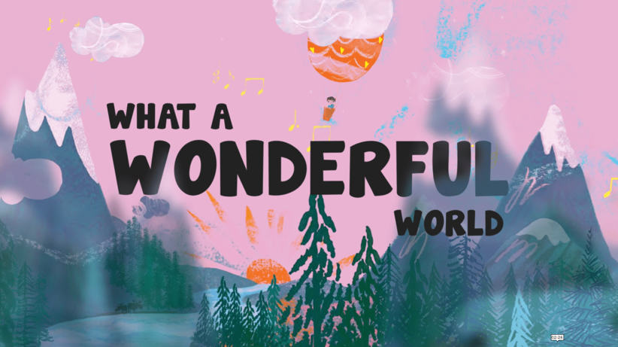

**Geography**

As geographers we will recap the hot and cold parts of the planet. We will then link learn about learning to animal habitats.

**Science**

**Living things and their habitats**

As scientists we will work scientifically by setting up a comparative test to find out and describe how plants need **light, temperature and water** to grow and stay healthy.

We will also be learning about what habitats are and that most living things live in habitats that are best suited to help them survive.

**Learn Together**

Our **Value of the Term** is **Courage and Perseverance**. In our Jigsaw lesson we will be setting goals and discussing our dreams for the future and what we think success looking like.

In Belief Systems, we are looking at changes to our local environment, thinking about whether changes are always good.

**Art and DT**

As artists we will be studying the creative work of Andy Goldsworthy and taking inspiration from his work to create our own natural art pieces.

**English**

As writers, we will be writing a Fear Tale and describing how our main character may overcome their fears. We will also be writing an acrostic poem linked to our topic. Finally, we will compose a non-chronological report linked to our science learning about habitats and Birds of Prey. We will continue to practise and refine our handwriting technique.

**P.E.**

Narwhal P.E. times: Wednesday and Thursday

Tiger P.E. time: Tuesday and Thursday

This term’s we will focus on: balance.

If you would like to contact the year 2 class teachers, please email [info@parklandset.org.uk](mailto:info@parklandset.org.uk)

Topic Vocabulary

Please read through these with your children and discuss their meaning. Why not try to incorporate some of these words into your day e.g. whilst playing or out for a walk.

**English Writing - Vocabulary**

**Vocabulary linked to core text:**

Frightened  
terrified

Dazzling  
magnificent  
dark  
midnight  
inky  
black  
soft  
fuzzy  
fluffy

**Vocabulary linked to grammar**

* Statement
* Question
* Exclamation
* Command
* Adjectives
* Coordinating conjunctions: *or/and/but*
* Subordinating conjunctions: *because./when/if/that*
* Past and present tense
* Adverbs e.g. quickly
* *Question mark*
* *Exclamation mark*

**Art**

Material  
natural  
sculptures  
manipulate  
land art  
observation  
texture – smooth, soft, bumpy, spikey

curved

**Geography**

maps  
landmarks  
features  
symbols  
human and physical features  
cliffs  
coasts  
hills  
North  
East  
South  
West  
Equator  
Hot  
Cold  
location

**Science – habitats**

habitat

needs

survival

alive  
dead  
food chain

animal

plants

warm  
cold  
dry  
damp

**Spelling   
Common Exception Words**

**Yr 1:**said  
were  
was  
they  
friend

**Yr 2:**

beautiful  
great  
plant  
could  
should  
would  
grass  
cold

-

**Learn Together**

Ready Respectful Safe

Courage  
Perseverance

Goal

Dream

Success

**Maths**

**Shape:** corners, vertices, sides, straight, curved,   
**Money:** coins, notes, pence, pounds, worth, value, change  
**Multiplication:** times, groups of, lots of, altogether,